(Approx. 532 words)

Broadsides
by Ron Broadhurst, Space Coast PC Users Group, Inc., Florida
www.scpcug.com
ringram728 (at) earthlink.net

This article has been obtained from APCUG with the author’s permission for publication by APCUG member groups; all other uses require the permission of the author (see e-mail address above).

These ideas are compiled from years of accumulations from various magazines, books, on-line sites, and my own personal experience. I claim neither originality nor ownership to any of its contents. My only intent is to share the various “tips, “tricks”, & “hints” in hopes of helping & maybe enhancing your computing experiences. They are all intended for anyone who uses a PC. It is for beginners as well as advanced users. Enjoy and use as you will.
Ron Broadhurst

I ACCIDENTALLY DELETED MY RECYCLE BIN IN VISTA - HOW DO I GET
IT BACK?
Go to Control Panel and click on the Personalization options:
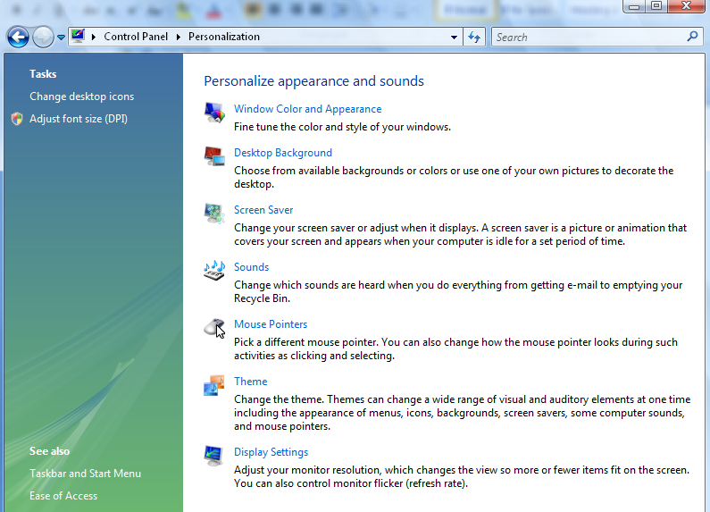
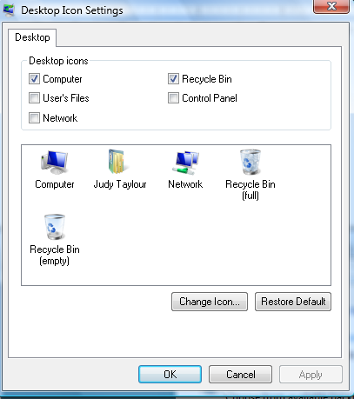
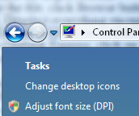

Click Change desktop icons and you’ll get this handy little dialog box: Click the Recycle Bin checkbox as highlighted above, click OK, and your Recycle Bin should reappear on the desktop.

PRINTING E-MAIL ADDRESSES IN OUTLOOK EXPRESS
TO PRINT YOUR Email Addresses:
Print each name and address on one line:
Open OUTLOOK EXPRESS click on File, Export, Address Book, Select Text File (Comma Separated Values) and click the Export button.
Name the file, click Browse button to save in Desktop. and at the bottom line, SAVE it in Text File (* .txt), click
Next, Deselect everything except NAME and Email Address then click Finish. Click on the Text File and Print it.

OUTLOOK EXPRESS ADDRESS BOOK BACK-UP
From Outlook Express, click on Tools/ Address Book, then File / Export / Address Book
Choose a storage location and give it a file name. Click save e-MAIL SHORTCUT /
RIGHT click on the Desktop and choose NEW then SHORTCUT.
In the Command line type mailto:yourfriend@whatever.whatever
For examplemailto:yourfriend@cfl.rr.com
Then click Finish and you have a short-cut to your E-mail friend. Double click and your e-mail opens up ready to go.

CONTROL PANEL SHORTCUTS
If you’re tired of multiple clicks to get to your floppy drive, CD-ROM drive, D-Drive, E-Drive or to the Control Panel, you can put a shortcut on your desktop for instant access.
Open MyComputer, RIGHT click on the icon for your floppy drive, CDRom drive, E or D-Drive or whatever you want and then select “Create Shortcut”. This will place an icon on your desktop for instant access to what you chose.

You can use this technique for any Folder you access frequently by putting the shortcut on your desktop. Now, your desktop becomes your operations center with quick access to any application, folder, or file on your PC.

SHORTCUT FOR SHORTCUT
You can assign a Keyboard key combination to any Shortcut. If you RIGHT click on any shortcut icon and choose Properties, you can then type Ctrl+any letter to assign the key combination that will open your Program. It should be a unique key and something you will remember. e.g. S for solitaire. This would be of great help if you wanted to go to another program when you cannot see your Desktop.

